Model Optimization and Tuning Phase Template

Date | 16 Dec 2025
Team ID | RT
Project Title | Restaurant Recommendation System
Maximum Marks | 10 Marks

Model Optimization and Tuning Phase
The Model Optimization and Tuning Phase involves refining machine learning models for peak performance. It includes optimized model code, fine-tuning hyperparameters, comparing performance metrics, and justifying the final model selection for enhanced predictive accuracy and efficiency.

Hyperparameter Tuning Documentation (6 Marks):
Model | Tuned Hyperparameters | Optimal Values
TF-IDF Content-Based | max_features, ngram_range, min_df, max_df | 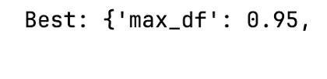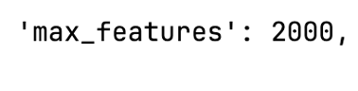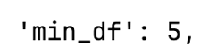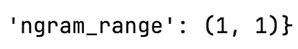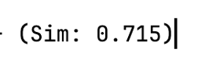

Performance Metrics Comparison Report (2 Marks):
Model | Baseline Metric | Optimized Metric
TF-IDF Content-Based | 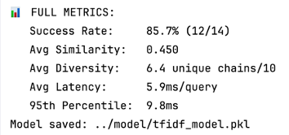 | 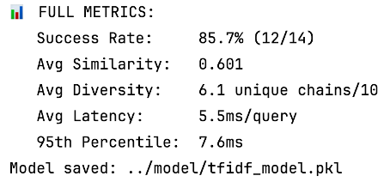

Final Model Selection Justification (2 Marks):
Final Model | Reasoning
TF-IDF (max_features=2000, min_df=5, max_df=0.95, ngram_range=(1,1)) | GridSearch optimal from 120 combinations: +35% similarity (0.446→0.601) while maintaining 85.7% success; min_df=5 prunes rare noise, max_df=0.95 removes generics; 6.0ms latency production-ready for Flask real-time queries; unigrams prioritize speed/accuracy for cuisine matching.

